McAULIFFE CHESS CLUB 2013-2014

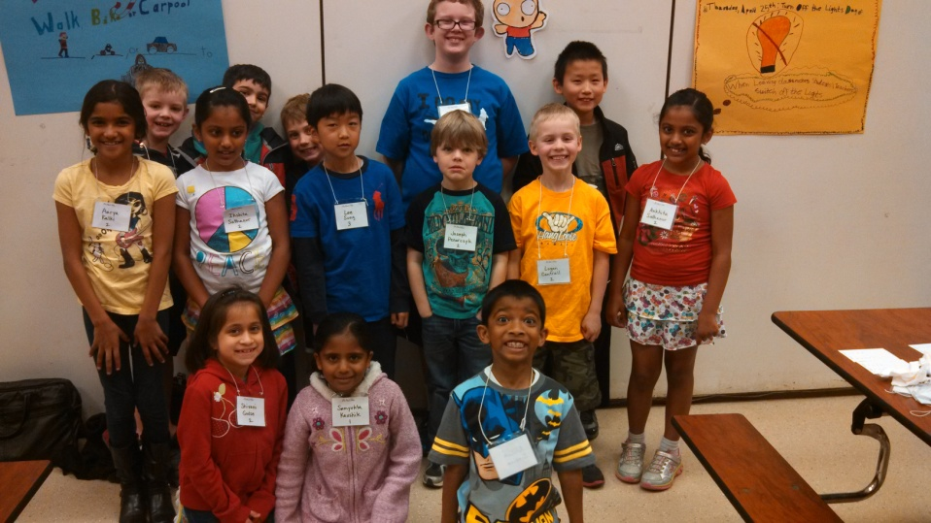
We are offering again a school chess club, running from October through April, which will allow kids to experience the learning and competition of chess. Students in grades K through 5 are invited to join the club. Chess is excellent at teaching kids mental discipline, to focus, to look at all their options, to compete under time pressure, to play fair, that mistakes have consequences, to not give up when behind, and many more life lessons.
David Hendricks is returning as the chess coach. Coach Hendricks has been coaching elementary chess clubs for 14 years. He has coached up to 10 elementary school chess clubs each year, including a team that took 1st in the nation 5 times and 1st in Washington State. He is the Scholastic Director for the Washington Chess Federation, and was the Director of the Microsoft Chess Club. He plays regularly in Washington and National Chess tournaments, coaches many private chess students, and runs summer chess and sports camps. He is an electrical and software engineer and designed computer hardware and software for Microsoft and Hewlett Packard.
I teach chess basics, openings, middle game strategies, end game principles, tactics such as pins, forks, skewers, distraction, X-rays, decoys damming, blockades, and many others. We cover checkmates, stalemates, how to determine when a piece is in trouble, how to escape trouble, how to attack and defend, how to look at all your options, preserve your material, improve your position, and how to compete. We will practice with chess clocks and will learn chess notation. Coach Hendricks uses a very interactive teaching style with lots of hands-on involved learning and feedback.
Meeting Times: Friday mornings before school from 7:30am to 8:45am (1 hour 15 minutes). We will meet in the commons. Got a conflict with Friday mornings? Contact the coach for options on other days at nearby schools.
Enrollment: We need a minimum of 15 kids to run the club – if we can’t get the minimum, chess club may be cancelled. Maximum is 30, if we get more than 30 we will take kids first by chess rating, and then limit attendance to first come, first served. We can accept all levels, beginner to advanced – most weeks I will divide the group into sections by skill level and teach different material to each group.
Dates: 1st meeting is the second week in Oct. Last meeting is the last week of Apr. We follow the Lake Washington District calendar - no club during days when there is no Friday morning school. We have 22 sessions – Oct 11, 25, Nov 1, 8, 15, 22, Dec 6, 13, 20, Jan 10, 17, 24, 31, Feb 7, 21, 28, Mar 7, 21, 28, Apr 4, 18, 25.
Tournaments: Tournament participation is optional but encouraged for those that are ready. We will target one Saturday tournament per month Nov - Apr in the greater Seattle area to test our skills against other schools. Tournaments usually run from 8:30am to 4:00pm – there are 5 games, each 1 hour long – kids play all 5 games win or lose. We need a good turnout to tournaments to win some team trophies. The coach will attend to review games and coach the kids. The State Championship is in April in Seattle WA this year - players need 3 out of 5 wins in any tournament to qualify for state.
Website: We will be using the ChessMagnetSchool.com website this year. This provides homework drills and tracks individual results. Students should plan to do 1 hour of chess homework per week (its fun!) from home or from any computer connected to the internet.
Cost: $264 per student for the full year - this is only $12.00 per week. This includes: 23 chess club sessions, the license fee for the chess website, all the chess equipment and supplies needed, handouts, in-class rewards and medals, the coach’s attendance at one Sat tournament per month, and year end party. Save money by paying for the full year up front, but you can also pay by halves – first half is Oct-Dec for $120, second half is Jan-Apr for $170. Sibling discount – subtract $40 for a second or third sibling in same family. Kindergartners: To be ready for chess, your kindergartner should be able to do simple math and some reading and writing. If you are not sure if your child is ready, I am offering a 4 week trial for $48 (for Kindergartners only). After 4 weeks, we can decide together whether to continue for the rest of the year (subtract $48 from full year tuition). Not included: tournament registration fees (about $15-$20 per tournament), and T-shirts.

Online registration for chess club! Follow these directions:

- Using your browser (Internet Explorer or Chrome or others) navigate to http://nwchess.com/OnlineRegistration.
- Find the McAuliffe Chess Club in the list of tournaments/clubs and click Register.
- Enter your student’s last name and click Search.
- If your child was in chess club last year, or has played before in a Northwest tournament, their name should appear in the list. Select it and click Edit and make any updates needed, then Save Changes.
- If your child has never played in a Northwest tournament, you will need to create a new database record for them. Click the New button; enter name, postal address, email address, phone, birth date, etc. Create your own password you can remember to protect your data. Enter grade (K, 1-5) and select CMC McAuliffe Elementary School from the pull-down list of schools, then click Get Rating Data. It will say Found 0 matching names in the NWSRS database. Choose “I intend to play in a NW scholastic tournament, and this will be my first time” and click Submit, then click Save Changes.
- Now click the Register button, enter your password, and choose a section (Full year 1st sibling, Full year 2nd or 3rd sibling, First half, Second half, or Kindergarten trial). Then click Submit, and Submit again.
- It should say Congratulations; you are now registered (when payment is received).
- To pay via Credit, Debit, or Paypal, click the Buy Now button (no online convenience fees).
- To pay via a check, write out a check to David Hendricks and bring to the 1st day of chess club.
- If the minimum number of students is not reached your money will be returned (minus a PayPal transaction fee of $.30).
- Joining after class has started? $12.00 * remaining sessions – pay by check only.

Registering for chess club automatically authorizes the following:

- Your child(ren) have your permission to access the ChessMagnetSchool.com website.
- You can volunteer for at least 2 sessions during the year (you will be contacted with a schedule). No chess knowledge needed – you will be monitoring kids and helping run the club.
- You understand there is no refund after class begins.

Chess Coach Chess Club Parent Director
David Hendricks Tammy Penarczyk
425-868-3881 home 425-896-2763 home
425-269-7949 cell
DavidCHendricks@comcast.net t.penarczyk@comcast.net

