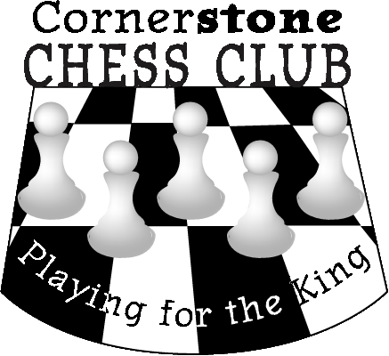
Bughouse Championships at the Washington State Elementary Championships!

Come have some fun the night before the big tournament by playing bughouse. The game is loud and fast action. And the players love it!

You can either preregister or register on site. Cutoff for the early registration discount is April 1st. You can register with someone, or don’t worry, we can pair you with someone at the tournament. Just be prepared for a great time!

Time: Onsite registration closes at 5:30 PM on Friday - Games start around 6 PM Friday.

Location: Clark County Event Center at the Fairgrounds main playing hall.

Format: Five Double Rounds (10 total games – winning team switches seats and colors, losing team stays in place, and you play a second time against new opponents). (Last groups may have slightly different format due to odd numbers of teams.)

A 6 team round robin format will be used based on the average rating of the team members. Each team will play the other 5 teams in the group. Since this is based on rating, all the games should be challenging for everyone! Some groups may have a different number of teams to make the overall groups fairly even.

Eligible: All Students (Grades K-9).

Awards: Each round robin group winner will receive a trophy - everyone gets something for playing!

Registration: Two Player Teams: IF you know who your partner will be, after you and your partner have both registered, go to the roster and select your name. Choose the option at the bottom to select a teammate – you will be able to select your partner from the list of registered players. If you do not know who your partner will be, you can either find a partner at check-in…or we will find a partner for you.

Entry Fee: $5 if registered before April 1st
$10 if registered after April 1st online
$10 on-site registration

Concessions: There will be some concessions on Friday from 3 PM to 7 PM, including hamburgers, curly fries, corn dogs, soda and water.

Rules/Miscellaneous: Come enjoy a fun and exciting evening of Bughouse Chess! This tournament is not rated, and will therefore not affect your rating. The Official Bughouse rules will be used; link to view rules: Northwest Chess Bughouse Rules

More Information: LATE ARRIVALS – Due to the format of the tournament, late arrivals will be welcome, but we may put you in a special group. You still need to register by the cutoff time.

Questions? Please contact us at: chess@playingForTheKing.com

