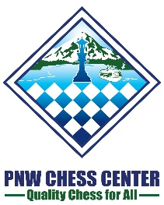
PNW Chess Center
Fund Raising Blitz & Pizza in Microsoft
Sunday August 26, 2018
Cafeteria 31/30
3910 163rd Ave NE, Redmond, WA 98052
Park your car in the parking lot in front of building 30. Then walk by building 30 to the café behind building 30.
BRING YOUR CHESS SET AND CLOCK!
Format, Section and Entry Fees:
- 11-round dual swiss
- USCF Blitz Rated
- Free entry with suggested donation $50+
Registration: Maximum of 80 players
- Online registration only at http://nwchess.com/OnlineRegistration/. Registration closes 1 hour before 1st round start. No onsite registration.
- Donation accepted online or onsite
Time Control:
- 3+2
Half-point byes:
- 3 half-point byes if announced before the start of round 2
Schedule:
Check in – 2:00PM - 2:30PM.
Round 1 starts at 2:30PM
Pizza dinner break at 6:30PM
Prizes: $0
All entry fees will be used by PNWCC for buying chess equipments. First place winner will be invited to play all PNWCC tournaments in the first month of PNWCC opening (tentatively October 2018) for free.
Organizer: Xuhao He (pnwchesscenter@gmail.com 425-213-7553)
Tournament Directors: Josh Sinanan, Jacob Mayer, Xuhao He, Vijay Sankaran

